Lab 13 - Internet Browser Forensics

Alex Arnold

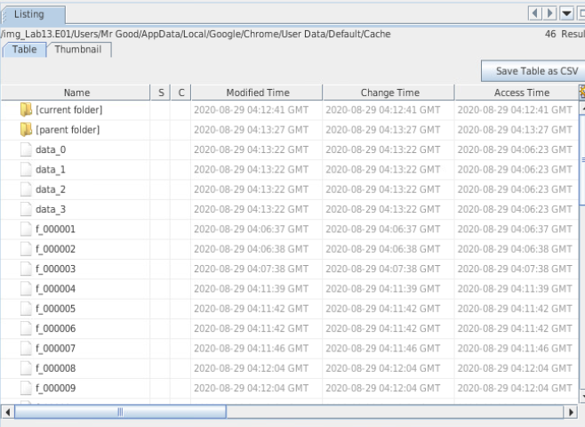

1.27 - Cache folder

2.13 - Thumbnail view

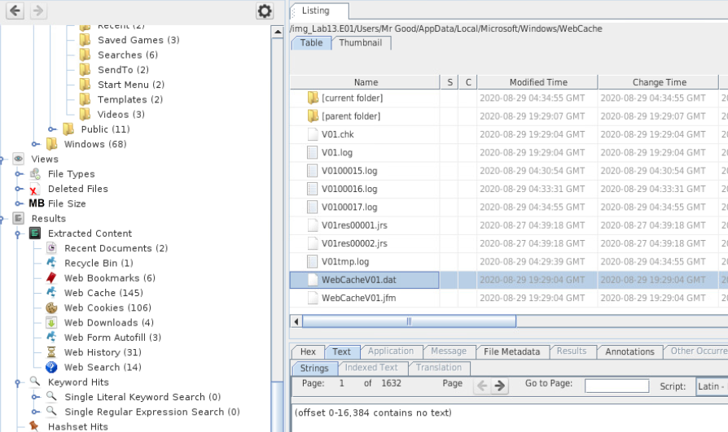

3.3 - Web history